Project Design Phase-II
Data Flow Diagram & User Stories

Date | 29 September 2026
Team ID | SWTID-2026-5599
Project Name | AI Study Buddy API
Maximum Marks | 4 Marks

Data Flow Diagrams:
The AI Study Buddy API manages the flow of information between students, administrators, application services, and databases. Students enter registration details, login credentials, profile information, study preferences, questions, messages, and schedule requests through the application. The API processes and transforms this information using authentication, study-partner matching, AI recommendations, group communication, and scheduling services. User profiles and account information are stored in the User Database, while study resources and learning data are stored separately. Group conversations and messages are maintained in the Study Group/Chat Database. The system returns authentication results, matching suggestions, AI responses, notifications, messages, resources, and schedule updates to users.

Example:
d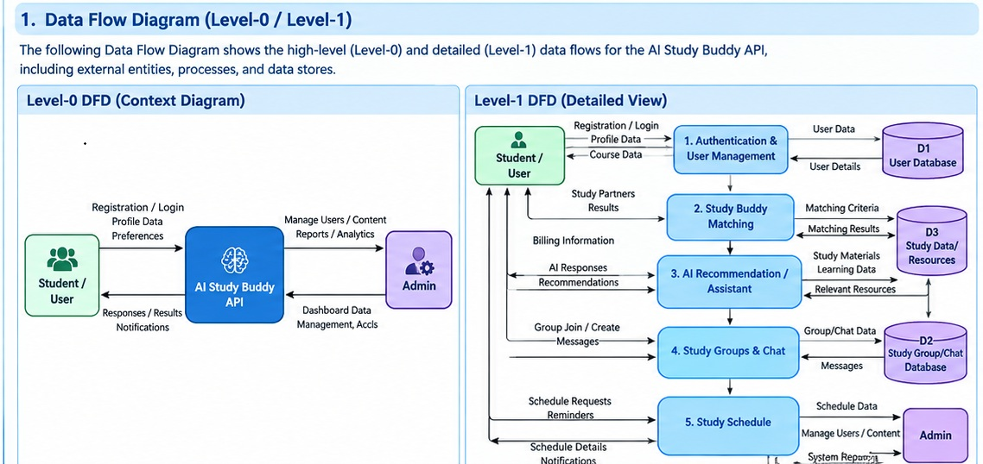

User Stories
Use the below template to list all the user stories for the product.
User Type | Functional Requirement (Epic) | User Story Number | User Story / Task | Acceptance criteria | Priority | Release
Customer (Mobile user) | Registration | USN-1 | As a user, I can register for the application by entering my email, password, and confirming my password. | I can access my account / dashboard | High | Sprint-1
Customer (Mobile user) | Login | USN-2 | As a user, I will receive confirmation email once I have registered for the application | I can receive confirmation email & click confirm | High | Sprint-1
Customer (Mobile user) | Profile Management | USN-3 | As a user, I can register for the application through Facebook | I can register & access the dashboard with Facebook Login | Low | Sprint-2
Customer (Mobile user) | Study Buddy Matching | USN-4 | As a user, I can register for the application through Gmail | Profile is saved and visible in app. | Medium | Sprint-1
Customer (Mobile user) | AI Study Assistant | USN-5 | I can find and connect with study partners based on preferences. | Matching results are shown with profiles and “Connect” option. | High | Sprint-1
Customer (Mobile user) | Study Groups | USN-6 | I can ask study questios and get AI explanation / recommendations. | A response is accurate and displayed with sources (if any). | High | Sprint-1
Customer (Mobile user) | Chat & Communication | USN-7 | I can create or join study groups. | Group is created/joined and visible is group list. | Medium | Sprint-1
Customer (Mobile user) | Study Schedule & Reminders | USN-8 | I can send and receive messages in groups or with study partners. | Messages are delivered in real-time and visible. | High | Sprint-2
Customer (Web user) | Resources & Progress | USN-9 | I can create study schedule and receive reminders. | Schedule is saved and reminders are triggered (push/in-app). | Medium | Sprint-2
Customer Care Executive | Notifications | USN-10 | I can access study resources and track my progress. | Resources are accessible and progress is updated. | Medium | Sprint-2
Administrator | User & Content Management | USN-11 | Manage users, groups, and content (ban/block, approve, delete). | Actions are reflected immediately and logged. | High | Sprint-2
Administrator | Analytics & Reporting | USN-12 | View usage statistics and reports. | Reports are generated and exportable (PDF/CSV). | Low | Sprint-2

